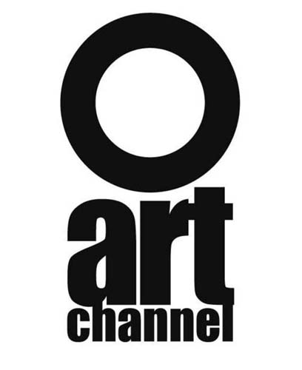 ART CHANNEL
Attn: Slobodan Atanaskovic
7, rue Adolphe Focillon / 75014 Paris FRANCE

APPLICATION FORM

I undersigned hereby submit my video artwork/s on DVD support to ART CHANNEL for selection.

Full name and address:
............................................................................................................................................................................................
……………………………………………………………………………………………………………………………

Tel: ……………………………………………………………
E-mail address: ……………………………………………….

Short CV / year of birth, professional qualification, short art biography:.............................................................................

................................................................................................................................................................................................................................................................................................................................................................................................

Title of the work: .............................................................................................................................................................

English title: ....................................................................................................................................................................

Duration: ...............................................................................................................................

Language: .............................................................................................................................

Year of production: ..............................................................................................................

Short description / concept:
................................................................................................................................................................................................................................................................................................................................................................................................................................................................................................................................................................................................

List of co-authors and co-producers, if any: ........................................................................................................................
...............................................................................................................................................................................................
...............................................................................................................................................................................................

BROADCAST PERMISSION

I undersigned, declare that I am authorized with no reserves and/or restrictions to dispose with rights for television broadcast of the work/s as described above. I hereby permit this work to be broadcast in TV program via satellites, terrestrial networks, cable, ADSL, internet and to be presented in exhibitions, festivals and other forms of presentation in the frame of the project “ART CHANNEL”.

These rights are not exclusive and they are granted free of charge for unlimited period of time and unlimited number of transmissions. This Permission is a guarantee against any claims that can be made for broadcast of the herein granted video material/work and is a declaration that no royalties are to be paid to any person or institution related to this work for the broadcast, rebroadcast and presentation in the frame of this project.

Work/s as described above may be withdrawn from the selection upon author’s written request.
If my artwork is selected for sale via “ART CHANNEL”, I will receive for approval a Form containing legal and financial terms of sale and if I accept them I will confirm it by my signature, in original, prior to the sale.

Signature: Date and place:

................................................................... ............................................................

N.B. : To be filled in original and sent along with the video artwork to :
ART CHANNEL
Attn : Slobodan Atanaskovic
7, rue Adolphe Focillon / 75014 Paris / France

